Change-Aware Siamese U-Net for Satellite-Based Post-Disaster Building Damage Segmentation with Grad-CAM Explainability
Sindhura.R  Department of Computer Science and Engineering  BNM Institute of Technology  Bangalore, India  sindhura1305@gmail.com | Chaitra M  Department of Computer Science and Engineering  BNM Institute of Technology  Bangalore, India  chaitram@bnmit.in | Thanmayee M K  Department of Computer Science and Engineering  BNM Institute of Technology  Bangalore, India  mkthanmayee76@gmail.com
Suhas R
Department of Computer Science and Engineering
BNM Institute of Technology
Bangalore, India
suhasrs2004@gmail.com

Abstract— Natural disasters including earthquakes, floods, and hurricanes often result in widespread structural damage, creating the need for fast and scalable assessment methods. This paper proposes an AI-driven post-disaster damage assessment framework that processes paired pre-disaster and post-disaster satellite imagery using a Siamese U-Net with change-aware temporal fusion. The network extracts features from pre-event and post-event image tiles through a shared encoder and combines temporal information at every scale by concatenating post-event features with the absolute difference between pre-event and post-event feature representations. The proposed framework, which was trained on an xBD-style dataset of 87 paired tiles in five damage tiers, obtains a Background class Dice score of 0.9428, an AUC of 0.8435, and an overall pixel accuracy of 88.27%. The interpretability of model predictions is strengthened by the spatially aligned saliency maps obtained from the Grad-CAM and Score-CAM explainability modules. Tile-level inference and ground truth comparison are rendered by an operational Streamlit dashboard, which facilitates practical implementation in actual catastrophe assessment.
Keywords: Disaster Assessment, Satellite Imagery, Siamese U-Net, Semantic Segmentation, Grad-CAM, xBD, Change Detection

Introduction
In numerous parts of the world, the frequency of natural disasters including hurricanes, wildfires, earthquakes, and floods has significantly increased in recent times. These incidents often result in a large number of fatalities, severe infrastructure damage, and major economic hardship. In order to facilitate emergency response and guarantee effective resource allocation, as well as direct both immediate recovery and long-term rehabilitation activities, it is crucial to quickly and accurately assess adversely affected regions. Due to restricted accessibility in disaster-affected areas, traditional damage assessment techniques rely mostly on physical inspections, which make the procedure labour-intensive and frequently delayed.
High-resolution satellite imagery is now accessible owing to recent developments in remote sensing, making it possible for the near real-time observation of vast geographic regions. Simultaneously, innovations in artificial intelligence, especially deep learning, have enabled highly efficient automatic analysis of complicated visual data. When combined, these technologies provide a reliable and scalable system for quantifying post-disaster damage across sizable affected areas. While convolutional architectures have developed to the point where pixel-level structure analysis from above-ground data is operationally tractable, recent developments in spaceborne imaging systems have made it viable to cover disaster-affected areas almost continuously at meter-scale resolution. This work brings these capabilities together in a unified pipeline that pairs a multi-scale decoder trained under a class-imbalance-aware objective on xBD-style annotated tiles with a change-aware Siamese encoder.The system provides a spatially registered saliency maps via Grad-CAM and Score-CAM, allowing analysts to confirm which picture regions caused each damage classification, and exposes forecasts using an interactive Streamlit interface to facilitate operational adoption.
The key contributions of this work are:
1. A Siamese U-Net with per-scale temporal difference fusion (concatenation of post features and |post - pre| features) for 5-class building damage segmentation.
2. A combined Soft Dice and weighted Cross-Entropy loss to address extreme class imbalance across five damage severity categories.
3. Integrated Grad-CAM and Score-CAM explainability targeting the final decoder convolution for spatially aligned saliency maps.
4. An operational Streamlit dashboard supporting tile-level inference on xBD-format satellite image pairs with ground truth comparison.

Literature Survey
Recent advancements in deep learning and remote sensing have significantly improved post-disaster damage assessment using satellite imagery. Researchers have increasingly focused on developing automated systems capable of identifying damaged buildings, classifying damage severity, and assisting emergency responders with rapid decision-making.
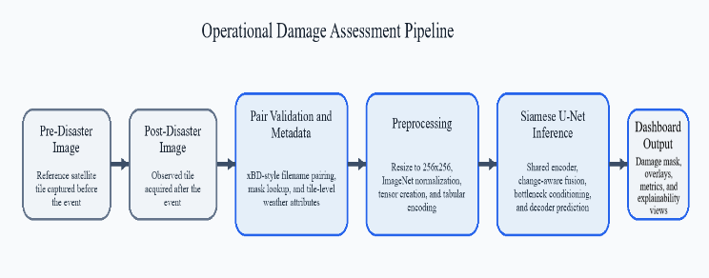
[1] Alisjahbana et al. addressed the challenge of building-level damage mapping by decomposing the problem into sequential localization and severity estimation stages, using bi-temporal satellite imagery as input. While their approach improved upon the xView2 competition baseline, it operates exclusively on visual data and does not account for auxiliary contextual signals such as terrain attributes or meteorological conditions that may influence damage patterns across different disaster types.
[2] Xue et al. demonstrated that incorporating structured property metadata alongside visual inputs can improve hurricane damage classification beyond what image-only models achieve. Their Swin Transformer-based architecture fuses street-level photographs with tabular fields including construction age and recorded wind exposure. The framework is tailored to a single disaster type and depends on ground-level imagery, constraining its applicability to wide-area satellite-based monitoring pipelines.
[3] Xiao and Mostafavi proposed a hierarchical transformer approach that moves beyond binary damaged/undamaged labelling toward finer structural typologies such as roof integrity and wall failure. The architecture reports strong segmentation quality metrics on post-event imagery, providing richer outputs for operational response planning. However, the system does not incorporate meteorological or geospatial auxiliary data and provides no mechanism for visual explanation of individual predictions.
[4] Gebre et al. explored cross-attention mechanisms operating over pairs of bi-temporal satellite tiles to produce multi-class building condition labels, with additional robustness to partially missing observations. Despite strong classification results, the framework is oriented toward feature-level fusion and does not generate spatially interpretable outputs that would allow an operator to verify which image regions drove a given prediction.
The reviewed studies demonstrate that deep learning has substantially advanced automated disaster damage assessment. However, most existing approaches either rely solely on satellite imagery or address segmentation and classification independently. Very few methods integrate change-aware temporal fusion, class-imbalance-robust training objectives, explainable saliency visualization, and an operational inference interface within a single unified framework. These gaps motivate the present work, which combines Siamese encoder-based temporal difference fusion, combined Dice and weighted Cross-Entropy loss, custom Grad-CAM and Score-CAM explainability, and a Streamlit dashboard for end-to-end post-disaster damage assessment.

Methodology
This section describes the end-to-end pipeline for post-disaster damage segmentation, covering dataset preparation, preprocessing, model architecture, loss formulation, and explainability. The overall system flow is illustrated in Fig. 1.

Fig 1. Operational damage assessment pipeline showing end-to-end flow from pre/post satellite tile pair to dashboard output.

Dataset and Pairing
The PRJ-3563 dataset comprises 87 paired satellite tiles in xBD format. Image filenames follow the pattern <tile_id>_<pre|post>_disaster.<ext>, enabling deterministic pairing of pre-event and post-event tiles by tile identifier. The training target is the post-disaster damage mask, which assigns each pixel to one of five classes: Background (0), No Damage (1), Minor Damage (2), Major Damage (3), and Destroyed (4). The dataset is split into 69 training tiles and 18 validation tiles. Class distribution is severely imbalanced, with Background and No Damage pixels dominating and Destroyed pixels being extremely rare.
Fig. 2 presents three representative tile pairs from the validation split, illustrating the visual diversity of pre/post imagery and the corresponding ground truth damage masks. The color overlay confirms the dominance of No Damage (green) and Background pixels across tiles, with Minor and Major Damage appearing at the building level and Destroyed pixels being visually sparse even in heavily affected scenes.
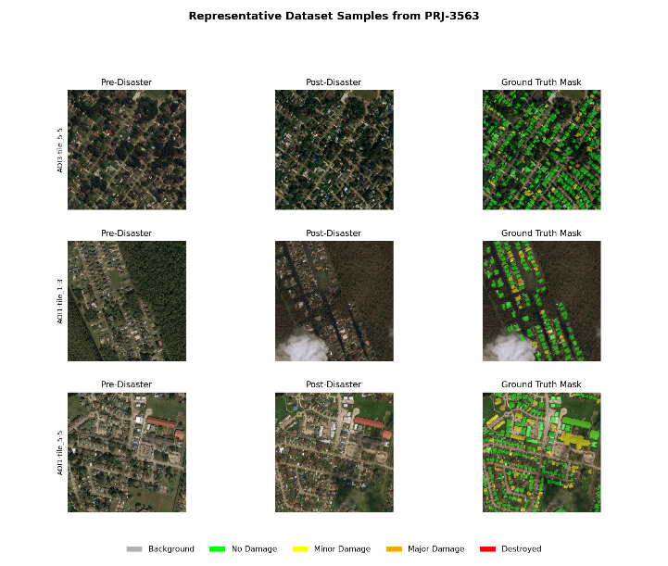
Fig 2. Representative pre/post image pairs and ground truth damage masks from the PRJ-3563 validation split. Overlay colors: green=no damage, yellow=minor damage, orange=major damage, red=destroyed.

Preprocessing
Input tiles are spatially resampled to a fixed 256×256 pixel resolution prior to network ingestion. Channel-wise intensity normalization follows the population statistics of the ImageNet corpus [20], a standard practice when initializing encoders with weights pretrained on large-scale visual recognition tasks. The normalized pre-event and post-event tensors are then stacked along the channel axis to produce a six-channel representation that serves as the unified input to the shared encoder.

Model Architecture - SiameseUNet
The proposed model is a Siamese U-Net in which a shared-weight encoder processes the pre-event and post-event image branches independently. At each of four encoder scales, temporal information is fused by concatenating the post-event feature map with the absolute difference between post-event and pre-event feature maps: fusion = concat(post_features, |post_features - pre_features|). Four decoder blocks with skip connections progressively recover spatial resolution, and a final 1x1 convolution produces a 5-class logit map. The architecture additionally supports optional FiLM-style tabular conditioning at the bottleneck for meteorological inputs (rainfall, wind speed, elevation, slope); this pathway was not activated in the current evaluation due to dataset constraints. The architecture is shown in Fig. 3.
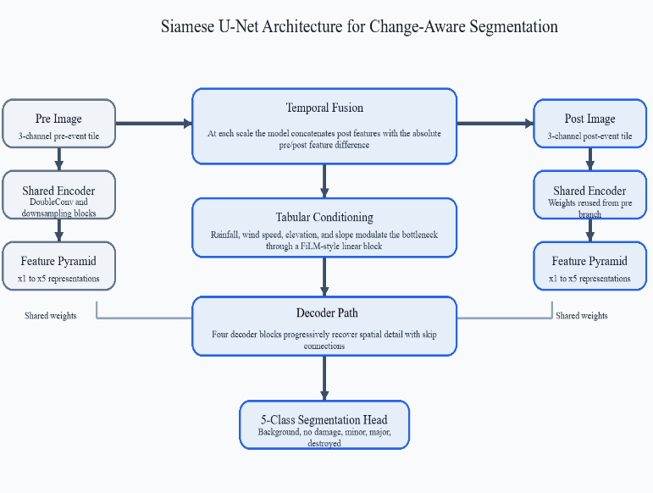
Fig 3. Siamese U-Net architecture with shared encoder, per-scale temporal difference fusion, and 5-class segmentation head.

Loss Function
The training objective is a linear combination of SoftDiceLoss and weighted CrossEntropyLoss, motivated by the complementary properties of the two terms [15]. CrossEntropyLoss penalizes per-pixel misclassification but is sensitive to class frequency, assigning disproportionately low gradients to rare categories. SoftDiceLoss directly optimizes the overlap between predicted and ground truth regions, providing a frequency-independent signal that benefits minority classes. Class weights for the CrossEntropy term are estimated from a full pixel-frequency scan of all 69 training masks, producing inverse-frequency weights that amplify gradient contributions from the Minor Damage, Major Damage, and Destroyed categories.

Explainability
A custom Grad-CAM implementation targets the final decoder convolution layer to produce class-discriminative saliency maps. Score-CAM is implemented as a gradient-free alternative. Both maps are normalized and upsampled to match the input resolution before being overlaid on the post-disaster image for spatial alignment, as shown in Fig. 4.
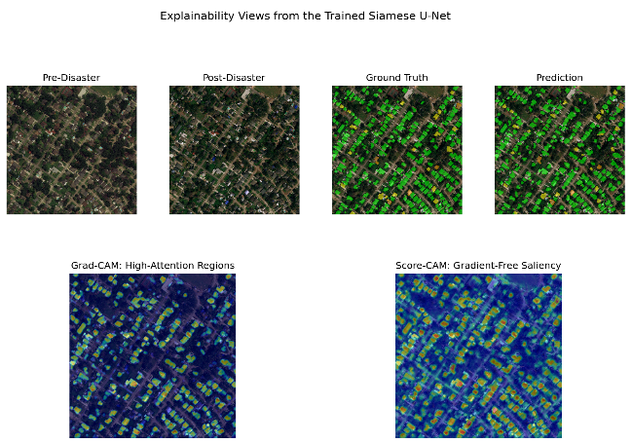
Fig 4. Explainability views from the trained Siamese U-Net: prediction panel (top) and Grad-CAM/Score-CAM saliency overlays (bottom).

Operational Dashboard
An operational Streamlit dashboard supports tile-level inference on xBD-format image pairs. Users can select dataset tiles or upload custom image pairs, view predicted damage masks, compare against ground truth annotations, and inspect Grad-CAM activation overlays. The dashboard is shown in Fig. 5.
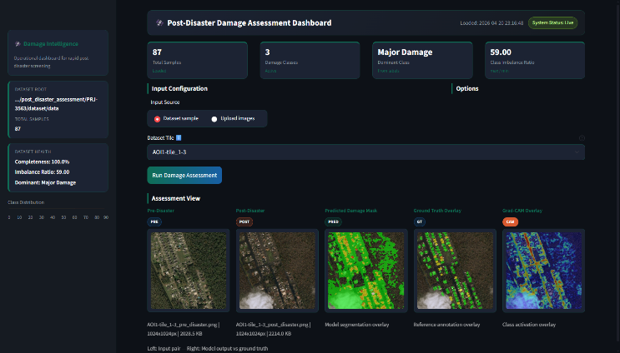
Fig 5. Operational Streamlit dashboard showing pre/post image pair, predicted damage mask, ground truth overlay, and Grad-CAM activation.

Experiments

Training Setup
Two training runs were conducted using the Adam optimizer with a learning rate of 1e-3 and weight decay of 1e-4, batch size 2, on the 69-tile training split. Data augmentation was enabled for the full training runs and disabled for baseline overfit testing.
The first run served as a 5-epoch operational baseline to validate end-to-end pipeline correctness, achieving a best validation Dice of 0.310. The primary model was trained for 100 epochs under identical hyperparameters, reaching a final training Dice of 0.9504, training IoU of 0.9063, and a best validation Dice of 0.8507. Training convergence for both runs is detailed in Section IV-B.
B. Implementation Details
The model was implemented in PyTorch with mixed-precision training disabled, keeping the pipeline reproducible on commodity hardware without distributed training requirements. The encoder applies four successive DoubleConv blocks with max-pooling for downsampling, producing feature maps at strides 1, 2, 4, and 8 relative to the input resolution. Each DoubleConv block consists of two 3×3 convolutions followed by batch normalization and ReLU activation. The decoder mirrors this structure with bilinear upsampling followed by convolutional refinement at each scale. Skip connections carry encoder feature maps directly to the corresponding decoder stage, preserving fine spatial detail lost during downsampling. The total number of trainable parameters is approximately 7.8 million. Checkpoints were saved at every epoch and the best validation Dice checkpoint was used for all reported evaluations. Fig. 6 illustrates the convergence behaviour across both training runs, confirming stable loss reduction and progressive metric improvement over 100 epochs.
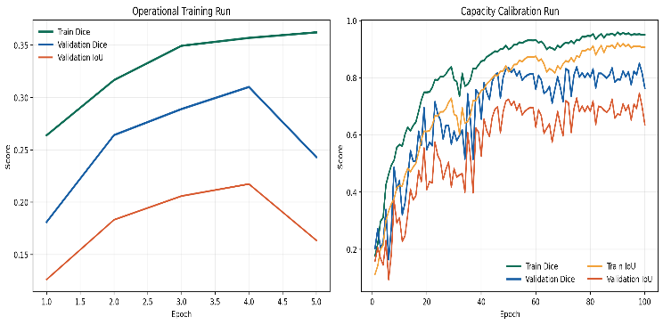
Fig 6. Training curves: 5-epoch operational baseline (left) and 100-epoch capacity calibration run (right). Primary model uses the 100-epoch checkpoint.

Results and Discussions

Quantitative Results
The trained Siamese U-Net was evaluated on the 18-tile validation split. Overall pixel accuracy reached 88.27% with an AUC of 0.8435. The macro-average Dice score is 0.4874 and macro-average IoU is 0.3811; these macro figures are depressed by the Destroyed class scoring 0.0 due to extreme pixel scarcity, and weighted averages better represent operational performance under this class imbalance. Per-class results are reported in Table II and visualized in Fig. 8.
- Overall Performance Metrics on the 18-Tile Validation Split
Performance Metric | Result
Overall Accuracy | 0.8827
Overall AUC | 0.8435
Macro-avg Dice Coefficient | 0.4874
Macro-avg IoU | 0.3811
Best Validation Epoch | 90
Train Dice (100-epoch run) | 0.9504
- Per-Class Dice and IoU Scores on the 18-Tile Validation Split
Class | Dice | IoU
Background | 0.9428 | 0.8917
No Damage | 0.6328 | 0.4628
Minor Damage | 0.4734 | 0.3101
Major Damage | 0.3881 | 0.2408
Destroyed | 0.0000 | 0.0000
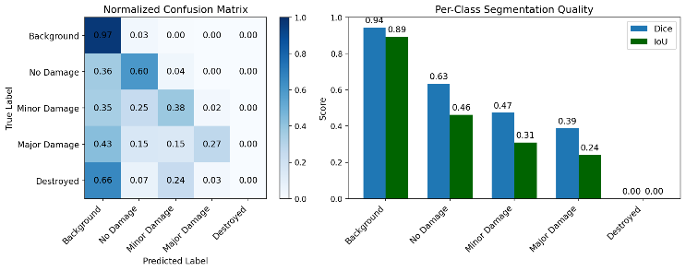
Fig 7. Normalized confusion matrix (left) and per-class Dice/IoU scores (right) on the 18-tile validation split.

Qualitative Results
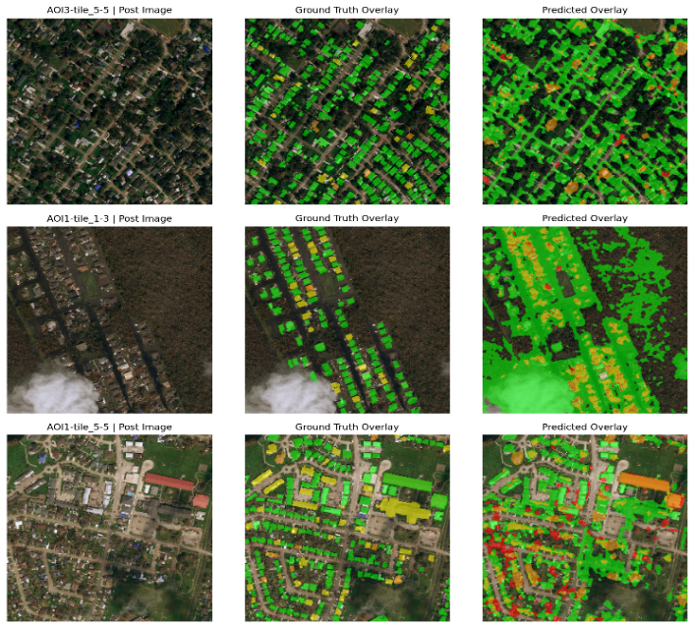
Three representative validation tiles are shown in Fig. 7. AOI3-tile_5-5 shows strong structural alignment between prediction and ground truth for no-damage and minor-damage classes. AOI1-tile_1-3 is a heavily flooded scene with partial cloud occlusion where the model over-predicts major damage in the flooded corridor. AOI1-tile_5-5 shows good building-level localization but elevated false positives for the destroyed class in dense residential areas.
Fig 8. Qualitative results on three validation tiles. Columns show post-disaster image, ground truth overlay, and predicted overlay. Color: green=no damage, yellow=minor, orange=major, red=destroyed.

Discussion
The proposed model demonstrates strong and consistent performance on the Background and No Damage classes, achieving Dice scores of 0.9428 and 0.6328 respectively. This indicates that the per-scale temporal difference fusion strategy is effective in capturing meaningful structural changes between pre-disaster and post-disaster satellite imagery. The model's high pixel accuracy of 88.27% and AUC of 0.8435 demonstrate its reliability in identifying large-scale damage, making it ideal for rapid assessment scenarios requiring speedy triage of impacted regions.
The findings do, however, also point to a glaring shortcoming in managing uncommon and serious damage classes. The performance gradually declines from Minor Damage (0.4734) to Major Damage (0.3881), while the Destroyed class achieves a Dice score of 0.0000, primarily due to extreme class imbalance in the dataset.
An overall pixel accuracy of 88.27% and an AUC of 0.8435 on an 18-tile validation set are obtained by using a combined Soft Dice loss and weighted Cross-Entropy loss to mitigate extreme class imbalance. The confusion matrix shows a significant bias towards Class Dice IoU Background, with values of 0.9428 0.8917 for No Damage, 0.6328 0.4628 for Minor Damage, and 0.4734 0.3101 for Major Damage (0.3881 0.2408). Approximately 66% of Destroyed pixels are wrongly tagged as Background, whereas 43% of Major Damage locations are misclassified as Background. This pattern suggests that the model is largely influenced by the dominant class distribution, causing it to prioritize common patterns over learning discriminative features for rare but critical damage categories.
Notwithstanding these drawbacks, the study offers insightful information about how the model makes decisions. The network continuously concentrates on important structural components including buildings, road networks, and densely populated areas, according to Grad-CAM representations, which is consistent with anticipated damage-related cues in satellite data. Score-CAM generates comparable attention maps without relying on gradient information, demonstrating the trustworthiness of highlighted regions. Confidence that the model is focusing on significant geographical regions rather than irrelevant background noise is increased by the agreement between the two approaches. Overall, the model works well for early-stage catastrophe assessment and general harm identification, although increasing sensitivity toward unusual and severe damage classes is still a crucial area for further research. Advanced rebalancing procedures, focal loss optimization, and dataset enlargement are among techniques that could be used to improve robustness in real-world disaster scenarios and overcome the existing bias.

Conclusion
Using xBD-style satellite images, this study presents a Siamese U-Net architecture with change-aware, per-scale temporal fusion for five-class building damage classification. By combining the Grad-CAM and Score-CAM explainability modules, the decoder pathway produces geographically consistent saliency maps, making damage assessment easier to understand and use. Future developments will concentrate on improving rare-class detection using larger datasets, focused loss-based optimization, and a thorough assessment of the suggested multimodal meteorological conditioning branch.

Future Work
Future improvements will focus on four directions. First, scaling training to the full xBD benchmark dataset to improve rare-class coverage, particularly for the Destroyed category. Second, applying focal loss or targeted oversampling strategies to reduce the background bias observed in the confusion matrix. Third, activating and evaluating the multimodal meteorological conditioning pathway using rainfall, wind speed, elevation, and slope inputs at the bottleneck. Fourth, extending the dashboard to support batch inference across entire disaster zones and integration with geospatial mapping tools for field deployment.

Acknowledgment
The authors sincerely express their gratitude to Chaitra M for her continuous guidance, constructive feedback, and unwavering support throughout the development of this work. Her expertise and encouragement were instrumental in the successful completion of the project.
The authors also wish to acknowledge the Department of Computer Science and Engineering, BNM Institute of Technology, for providing the essential resources and a supportive environment that facilitated research and development activities.

References
- I. Alisjahbana, J. Li, B. Strong, and Y. Zhang, “DeepDamageNet: A Two-Step Deep Learning Model for Multi-Disaster Building Damage Segmentation and Classification Using Satellite Imagery,” arXiv preprint arXiv:2405.04800, 2024.
- Z. Xue, X. Zhang, D. O. Prevatt, J. Bridge, S. Xu, and X. Zhao, Post-Hurricane Building Damage Assessment Using Street-View Imagery and Structured Data: A Multi-Modal Deep Learning Approach,” arXiv preprint arXiv:2404.07399, 2024.
- Y. Xiao and A. Mostafavi, “DamageCAT: A Deep Learning Transformer Framework for Typology-Based Post-Disaster Building Damage Categorization,” arXiv preprint arXiv:2504.11637, 2025.
- T. S. Gebre, J. Talreja, and L. Hashemi-Beni, “Multi-Modal Attention for Automated Disaster Damage Assessment Using Remote Sensing Imagery and Deep Learning,” arXiv preprint arXiv:2606.14963, 2026.
- C.-F. Liu, L. Huang, K. Yin, S. D. Brody, and A. Mostafavi, “FloodDamageCast: Building Flood Damage Nowcasting with Machine Learning and Data Augmentation,” International Journal of Disaster Risk Reduction, vol. 113, 2024.
- Y.-H. Ho, C.-C. Lee, N. Diaz, S. D. Brody, and A. Mostafavi, “ELEV-VISION: Automated Lowest Floor Elevation Estimation from Segmenting Street View Images,” ACM Journal on Computing and Sustainable Societies, vol. 1, no. 2, 2024.
- K. Yin, B. Li, C. Liu, A. Mostafavi, and X. Hu, “CrisisSense-LLM: Instruction Fine-Tuned Large Language Model for Multi-Label Social Media Text Classification in Disaster Informatics,” arXiv preprint arXiv:2024.XXXX, 2024.
- Y.-H. Ho and A. Mostafavi, “Flood-DamageSense: Multimodal Mamba with Multitask Learning for Building Flood Damage Assessment Using SAR Remote Sensing Imagery,” International Journal of Disaster Risk Reduction, 2025.
- D. Martin et al., “xView2 Challenge: Building Damage Assessment from Satellite Imagery,” arXiv preprint arXiv:1911.09296, 2019.
- R. C. Daudt, B. Le Saux, and A. Boulch, "Fully Convolutional Siamese Networks for Change Detection," in Proc. IEEE Int. Conf. Image Processing (ICIP), 2018, pp. 4063–4067.
- H. Chen and Z. Shi, "A Spatial-Temporal Attention-Based Method and a New Dataset for Remote Sensing Image Change Detection," Remote Sensing, vol. 12, no. 10, p. 1662, 2020.
- R. Gupta et al., "Creating xBD: A Dataset for Assessing Building Damage from Satellite Imagery," in Proc. IEEE/CVF Conf. Computer Vision and Pattern Recognition Workshops (CVPRW), 2019.
- O. Ronneberger, P. Fischer, and T. Brox, "U-Net: Convolutional Networks for Biomedical Image Segmentation," in Proc. Int. Conf. Medical Image Computing and Computer-Assisted Intervention (MICCAI), 2015, pp. 234–241.
- R. R. Selvaraju, M. Cogswell, A. Das, R. Vedantam, D. Parikh, and D. Batra, "Grad-CAM: Visual Explanations from Deep Networks via Gradient-Based Localization," Int. J. Computer Vision, vol. 128, pp. 336–359, 2020.
- C. H. Sudre, W. Li, T. Vercauteren, S. Ourselin, and M. J. Cardoso, "Generalised Dice Overlap as a Deep Learning Loss Function for Highly Unbalanced Segmentations," in Proc. Deep Learning in Medical Image Analysis Workshop, 2017, pp. 240–248.
- H. Wang, Z. Wang, M. Du, F. Yang, Z. Zhang, S. Ding, P. Mardziel, and X. Hu, "Score-CAM: Score-Weighted Visual Explanations for Convolutional Neural Networks," in Proc. IEEE/CVF Conf. Computer Vision and Pattern Recognition Workshops (CVPRW), 2020.
- N. Sublime and E. Kalinicheva, "Automatic Post-Disaster Damage Mapping Using Deep-Learning Techniques for Change Detection: Case Study of the Tohoku Tsunami," Remote Sensing, vol. 11, no. 9, p. 1123, 2019.
- E. Perez, F. Strub, H. de Vries, V. Dumoulin, and A. Courville, "FiLM: Visual Reasoning with a General Conditioning Layer," in Proc. AAAI Conf. Artificial Intelligence, 2018, pp. 3942–3951.
- L. Zhang, L. Zhang, and B. Du, "Deep Learning for Remote Sensing Data: A Technical Tutorial on the State of the Art," IEEE Geoscience and Remote Sensing Magazine, vol. 4, no. 2, pp. 22–40, 2016.
- K. He, X. Zhang, S. Ren, and J. Sun, "Deep Residual Learning for Image Recognition," in Proc. IEEE Conf. Computer Vision and Pattern Recognition (CVPR), 2016, pp. 770–778.
- S. Ji, S. Wei, and M. Lu, "Fully Convolutional Networks for Multisource Building Extraction from an Open Aerial and Satellite Imagery Data Set," IEEE Trans. Geoscience and Remote Sensing, vol. 57, no. 1, pp. 574–586, 2019.

